**Creating a Prezi presentation**

Presentation Online Tools training: <https://prezi.com/view/X3JjchKQ0knHieFHf5xe/>

Introduction video: [Prezi tutorial: Get started in Prezi](https://www.youtube.com/watch?v=Hqw0PzOTqOY)

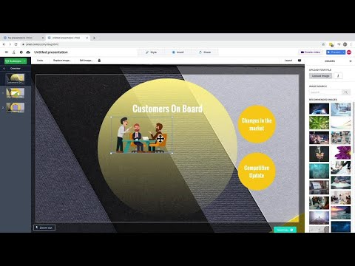

Presentation gallery: <https://prezi.com/gallery/?click_source=logged_element&page_location=footer&element_text=gallery>

Design tips: [https://prezi.com/p/3r1-5fqkm9fh/week-2-principles-of-graphic-design/?](https://prezi.com/p/3r1-5fqkm9fh/week-2-principles-of-graphic-design/?click_source=logged_element&element_type=prezi_card&element_text=3r1-5fqkm9fh)