# Zoom Guidelines for Participants

This guide has been prepared to enable you to have an effective and efficient Zoom training. It includes a checklist to cover prior to the seminar, an explanation of the Zoom controls and a brief troubleshooting guide.

## Pre Seminar Checklist:

* We strongly advise you to, where possible join, the session from the **Zoom desktop application**. This is to ensure you’re online learning experience is not curtailed due to the limited functionalities of the other versions of Zoom. Although the basic tools can be accessed through the other Zoom platforms, certain Zoom functions are not available if you are not using the desktop application.
* For the best possible experience, please consider **connecting your device directly via an Ethernet cable to your rooter** or placing your device in **close proximity to your WIFI-emitter**.
* Interaction during the session enhances the learning experience, therefore please **check the audio (and ideally the video capabilities) of your device beforehand**. A short audio check (welcome round) will be performed at the beginning of each session to see if all participants can follow the session. There is a step-by-step guide at the end of this document on checking your audio settings.

Directly after joining a session:

* Please **mute your microphone** until it is your turn to speak (e.g. during your turn in the welcoming round) to avoid general confusion due to unforeseen background noise. You will find instructions on how to mute your microphone below.
* Turn your camera on where possible. This is to promote an effective and interactive session for all involved.
* We are keeping record of the attendance and crosscheck this with the list of registered participants, therefore (after joining a session) please **double-check if you are currently logged into the session with a clearly identifiably name**. This can be done by clicking on button ‘participants’, then hovering above your name in the list and clicking ‘rename’ (if your current name deviates from your first- & last name).

## Zoom Controls

https://assets.zoom.us/images/en-us/desktop/generic/in-meeting/attendee-controls.png

Attendees have access to these features in order of left to right:

1. **Mute**/**Unmute:**Mute and unmute your microphone.  
   Audio Controls (click the **^** arrow next to **Mute**/ **Unmute**): Allows you to change the microphone and speaker that Zoom is currently using on your computer, leave computer audio, and access the full [audio settings](https://support.zoom.us/hc/en-us/articles/201362623-About-Settings).
2. **Start Video**/ **Stop** **Video**: Turns your camera on or off.  
   Video Controls (click the ^ arrow next to **Start Video**/ **Stop Video**): Change cameras if you have multiple cameras, select a [virtual background](https://support.zoom.us/hc/en-us/articles/210707503-Virtual-Background) (if enabled), or access your full [video settings](https://support.zoom.us/hc/en-us/articles/201362623-About-Settings).
3. **Participants**: See who's currently in the meeting. You can also access to these options. From this list you can change your screen name (via **Rename**) and offer non-verbal feedback (see below)
4. **Chat**: Access the chat window to chat with the participants (see below).
5. **Share Screen**: this function will be seldom used by participants during our training sessions.
6. **Record: this function will not be used during our training sessions.**
7. **Reactions**: share a brief (60 second) reaction of a thumbs up or a applause with the host and the other participants.

### Chat

Using the **chat tool** can encourage engagement by allowing more participants to interact with the live activity, rather than just listening.

Chat allows posts to the **whole class or privately to one other person**. This can be done by selecting the person's name right above the Textbox where you type your messages.

### Non-Verbal Feedback

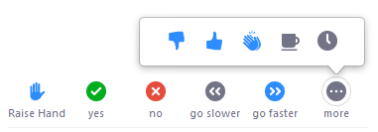

**Participants can place an icon beside their name** to communicate with the host and other participants without disrupting the flow of the seminar. This is known as non-verbal feedback.

For example, clicking **Raise Hand** places the raise hand icon beside your name to simulate a hand raise.  The participants can also indicate if they want the presenter to speak **slower/faster**, if they **need a break** or to simply answer **Yes or No**.

All participants can see the icons that everyone else has chosen. In addition, the host sees a summary of how many participants are displaying each icon, and has the option to remove all feedback.

You can access the non-verbal feedback by going to the participants list and selecting an icon. You can only display one icon at a time.

## Additional Zoom functionalities

### Break out rooms

Break out rooms allow the trainer to organize a group of participants into individual groups, similar to face-to-face experiences. Break out rooms allows these sub-groups to work independently from the main group. The host controls who is in each group and how long the groups can meet. You can contact the host from your break out room by selecting the **Ask for Help** in the meeting controls. Further clarification on break out rooms will be provided by your trainer.

## Technical Issues

If you are having **technical issues**, we would first advise you to test your camera/audio device. You can find instructions on how to do this below.

**Test your camera, microphone and speakers/headset.**

To test audio

You can test your audio using the **pop up that appears when you try to start your session**

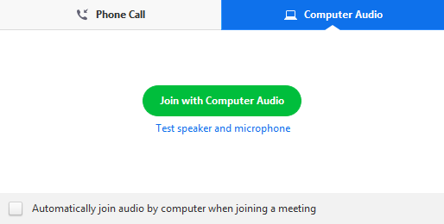

The audio can also be tested during a meeting by **clicking the arrow next to Mute/Unmute button** and selecting Audio Options. This will open your audio settings.

To test camera

1. Click the arrow next to **Start Video** / **Stop Video**.

https://assets.zoom.us/images/en-us/desktop/generic/start-stop-video-button-arrow.png

1. Select **Video Settings**.

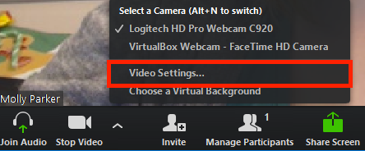

1. Zoom will display your camera's video and settings.

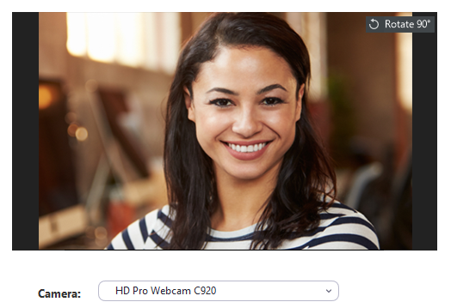

1. If you do not see your camera's video, click the drop-down menu and select another camera.