Cisco Webex Guide for Participants

This guide has been prepared to provide you the tools to have an effective and efficient Cisco Webex training. It includes a checklist to cover prior to the online course, an explanation of the Cisco Webex controls and a brief troubleshooting guide.

Pre-course checklist:
- We advise you to join the session through the Cisco Webex desktop application. This is to ensure that your online learning experience is not curtailed due to the more limited functionalities of the browser version of Cisco Webex (e.g. no possibility to partake in polls). However, we understand that this is not always a possibility and our trainings are designed so that you can still fully participate via the browser version, which can be done by following the assigned link.
- For the best possible experience, please consider connecting your device directly via an Ethernet cable to your rooter or placing your device in close proximity to your WIFI-emitter.
- Interactions during the session enhances the learning experience, therefore we advise you to check the audio, microphone and video capabilities of your device before the start of the session. Ideally, this is to be done by opening the audio settings and enabling the test functionality to ensure that all the devices are prompt. A short audio check (welcome round) will be performed at the beginning of each session to see if all participants can follow the session. There is a step-by-step guide at the end of this document on checking your audio settings.
Joining a Meeting
In order to participate in a Webex meeting, you will receive an invite communication with instructions coupled with a link to our Cisco Webex session. You can click the Join meeting link to connect. In some cases, you might be asked to enter a meeting a password. You would be able to find it in your email invitation.
In addition, Cisco Webex provides the option to join via Desktop app or web browser. Ideally, we would advise you to use the desktop version of the application, however, we understand that this it not possible in all cases. Nevertheless, it is still possible to join our trainings via your web browser by following the invitation link, and clicking “join via the browser”.
We would like to emphasize that we are keeping record of the attendance and crosscheck this with the list of registered participants, therefore (after joining a session) please double-check if you are currently logged into the session with a clearly identifiable name. However, it is important to note that Cisco Webex doesn’t provide for a renaming option, and that in order to change your name, you would have to disconnect and connect to the session with the right credentials.
Directly after joining a session:
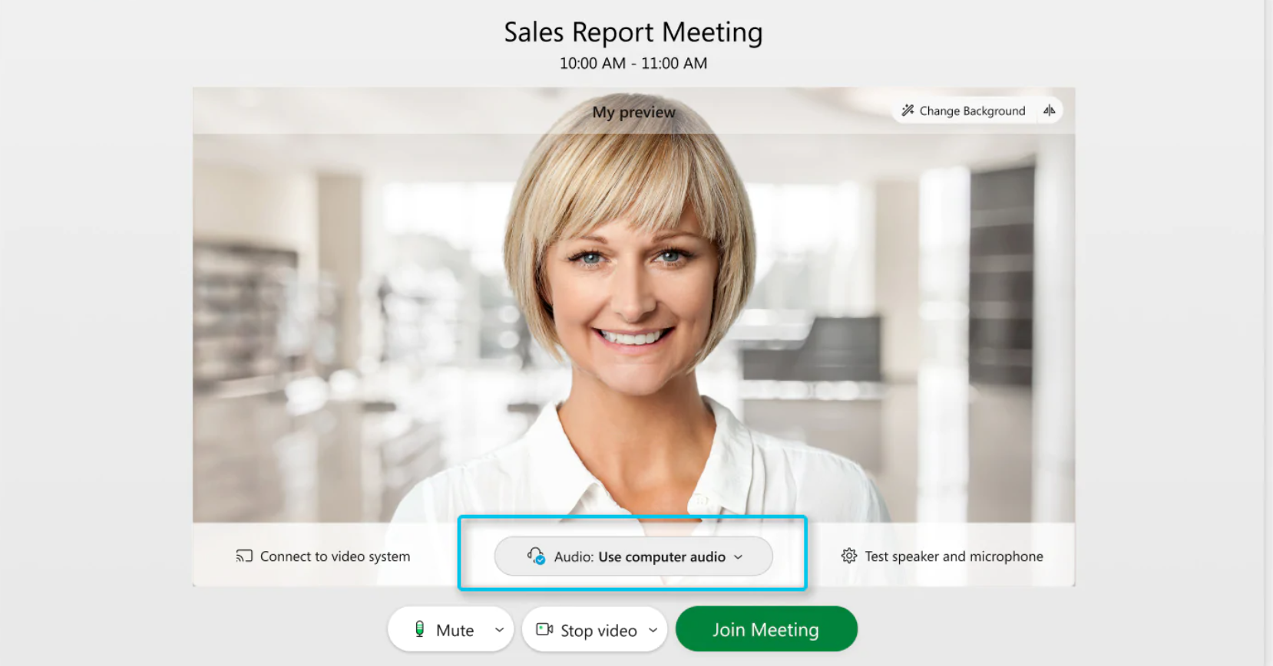
Picture provided by help.webex.com
- Please mute your microphone until it is your turn to speak (e.g. during your turn in the welcoming round) to avoid general confusion due to unforeseen background noises.
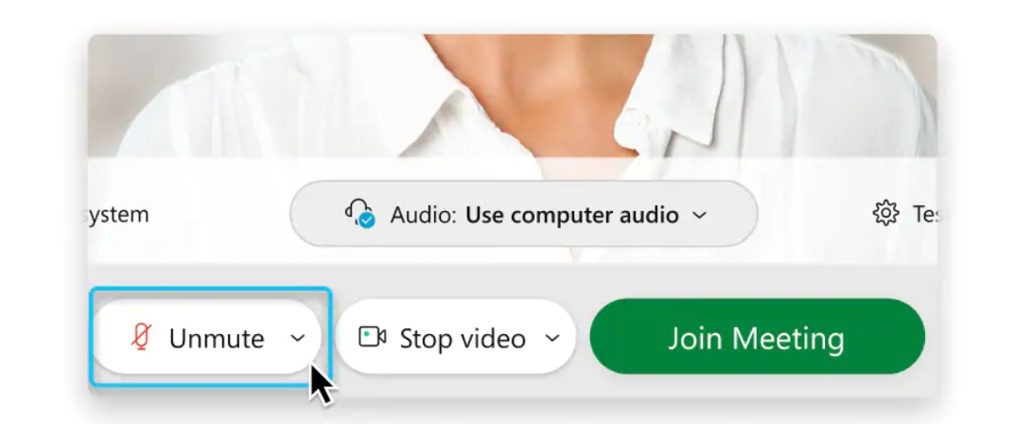
Picture provided by help.webex.com

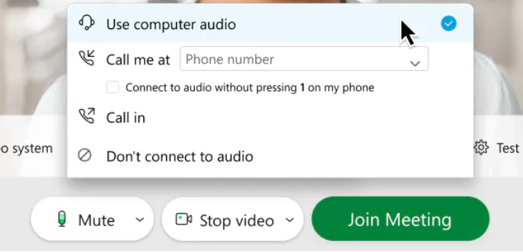
Picture provided by help.webex.com
- Use computer audio—Use your computer with a headset or speakers. This is the default audio connection type. – You can change your headset, speakers, and microphone.
- Call me—Enter or select the work or home phone number that you'd like the meeting to call.
- Call in—Dial in from your phone when the meeting starts. A list of global call-in numbers is available after you join the meeting.
  - Don't connect to audio—You won't hear any audio in the meeting through your computer or phone. Use this option if you're in the meeting room but want to use your computer to share content in the meeting

- Please turn your camera on whenever possible; this enhances the experience not only for our trainers but also all participants, and helps markedly during the interactive elements of our courses.

Webex controls

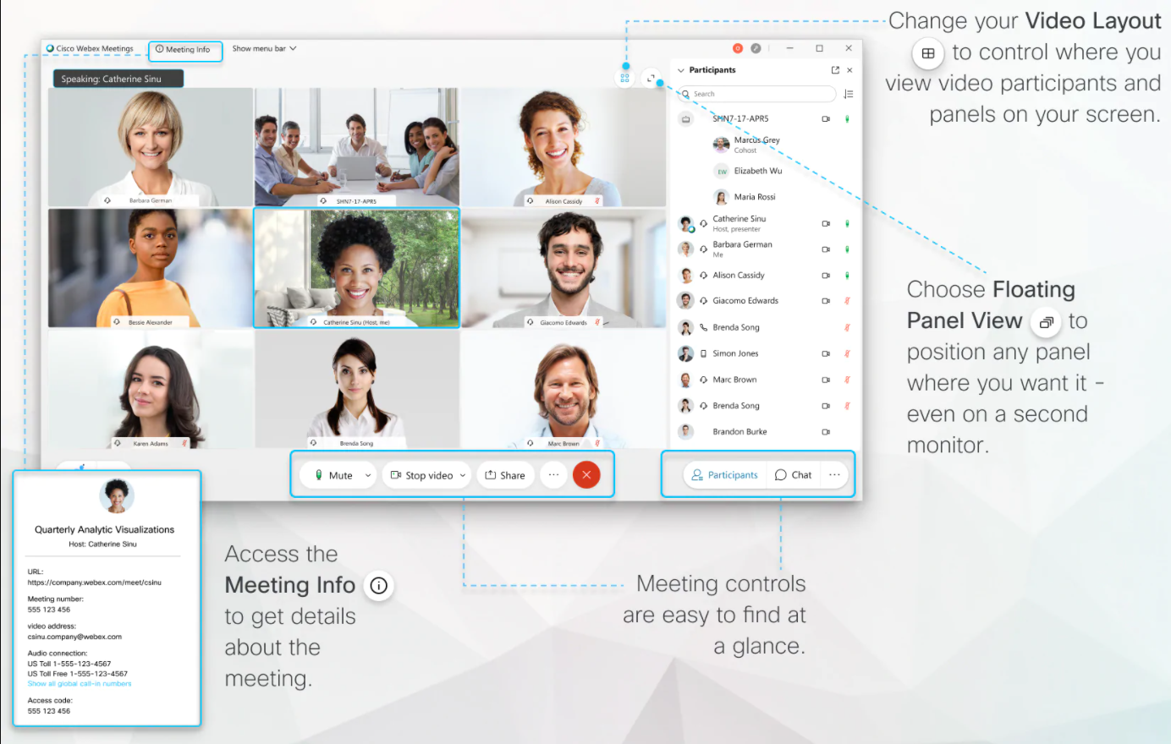
Picture provided by help.webex.com

Attendees have access to these features in order of left to right:
- Mute / Unmute: Mute and unmute your microphone.
Audio Controls (click the ^ arrow next to Mute / Unmute): Allows you to change the microphone and speaker that webex is currently using on your computer, leave computer audio, and access the full audio settings.

- Start Video / Stop Video: Turns your camera on or off.
Video Controls (click the ^ arrow next to Start Video / Stop Video): Change cameras if you have multiple cameras, select a virtual background (if enabled), or access your full video settings.

- Share Content: This function is often only used by our trainers but can be part of interactive elements of courses, more specific instructions will be given before such exercises take place. In case that the button is not available, that means that the function was disabled by the host of the meeting.

- Participants: See who's currently in the meeting. You can also access to these options. From this list you can offer non-verbal feedback (see below)

- Chat: Access the chat window to chat with the participants (see below). In addition to that, the drop-down button after opening the chat offers the functionality to select the recipients of the message.
- Notes: This function is always available for the participants to take notes within the cisco webex environment.

- Reactions (emoji button): Shares a brief (60 second) reaction of non-verbal communications.

Chat
Using the chat tool can encourage engagement by allowing more participants to interact with the live activity, rather than just listening.
The chat allows messages to be sent to the whole class or privately to one other person. This can be done by selecting the person's name right above the Textbox where you type your messages.
Instructions on which trainer/moderator should be contacted for questions in general or issues during exercises are given at the beginning of courses.

Non-Verbal Feedback

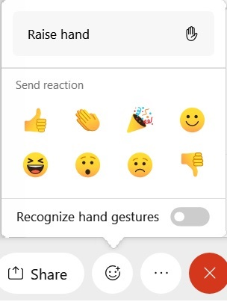
Participants can place an icon beside their name to communicate with the host and other participants without disrupting the flow of the seminar. This is known as non-verbal feedback. You can access the non-verbal feedback by going to the participants list and selecting an icon. You can only display one icon at a time.

For example, clicking Raise Hand places the raise hand icon beside your name to simulate a hand raise. The participants can also indicate if they want the presenter to speak slower/faster, if they need a break or to simply answer Yes or No.

All participants can see the icons that everyone else has chosen. In addition, the host sees a summary of how many participants are displaying each icon, and has the option to remove all feedback.

Technical Issues regarding...

Connection to the training: We recommend using an up-to-date browser (e.g. Chrome, Edge, Firefox, Safari) to connect to our sessions. We have had a few experiences where Internet Explorer was often the source of connection problems.

Low internet bandwidth: First step would be to turn off your own camera to see if this alleviates the stress on your connection sufficiently. Using both the camera and the microphone requires a lot of internet bandwidth. If this is not the case, you can participate visually via Webex while conducting the audio connection via your phone line by clicking the ^ arrow next to Mute / Unmute button and selecting “Switch to Phone audio” and follow the instruction of the pop-up.

Problems with the audio or camera: we would first advise you to test your camera/audio device (instructions on how to do this below). It may be that your webex call is connected to a different audio device / camera.

Another potential issue is that you have logged into the Cisco Webex session from within a company's virtual desktop/cloud network, which makes it difficult for Cisco Webex to find the camera and microphone of your physical device. To avoid this issue, we strongly recommend connecting to the session from outside the cloud desktop.
Testing Audio
In order to test while joining the meeting on Webex, click Settings in the lower-right corner of the preview window, and skip to Step 3.
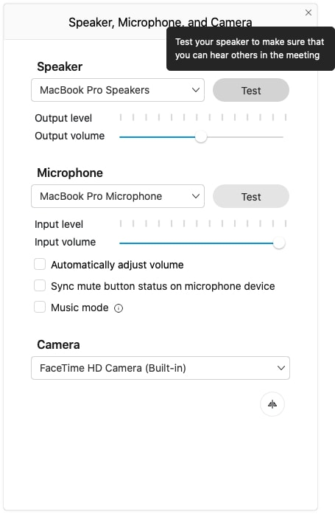

- To test during the meeting, go to More options, and select speaker, microphone, or camera.
- In the Speaker menu, click Test.
- If you don't hear anything, try changing the speaker device in the drop-down list, or adjusting the Output volume slider.
- In the Microphone menu, click Test, and then speak into your microphone.
After a moment, a recording of your test will automatically play back to you.
If you don't hear the audio play back, try selecting a different microphone from the drop-down list, or adjusting the Input volume slider.

Picture provided by help.webex.com

